wk1_assign_A_php1.doc

Topic: Create a PHP enabled web page.

Task #1: *“Creating a simple PHP enabled web page.*

* See the resulting output below.
* Note: Include a single line comment in the program
* Include {YOUR NAME} on the web page!
* Include the images found in the posted file: wondersImages.zip
* ALL OUTPUT MUST BE DISPLAYED USING PHP CODING!
* Save the text file as wonders.php

POST to college Web Server:

* Post your program file and images to the Web server using FileZilla.

Test your PHP program:

* *Open your browser, load the page, and test!*

The output of wonders.php

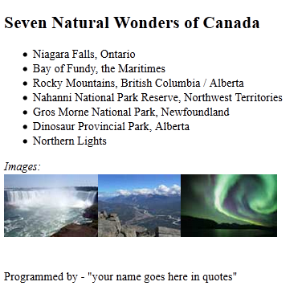

Note: All output must be displayed using PHP coding (i.e. echo() function)

Note: Your name must display (in quotes) on the web page, for marks to be given for this assignment.

wk1_assign_A_php1.doc